Eucharistic Evening Prayer II
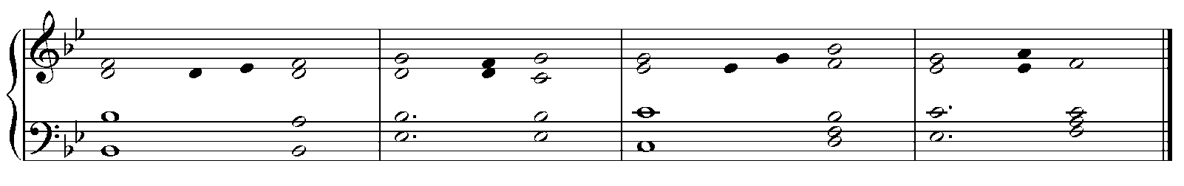
Canticle of Mary

Cantor: How holy this feast in which Christ is our food;
his passion is recalled;
grace fills our hearts;
and we receive a pledge of the glory to come.

All: My soul proclaims the greatness of the Lord,
my spirit rejoices in God my Savior
for he has looked with favor
on his lowly servant.

From this day all generations
will call me blessed:
the Almighty has done great things for me
and holy is his Name.

He has mercy on those who fear him
in every generation.
He has shown the strength of his arm,
he has scattered the proud in their conceit.

He has cast down the mighty from their thrones,
and has lifted up the lowly.
He has filled the hungry with good things,
and the rich he has sent away empty.

He has come to the help of his servant Israel
for he has remembered his promise of mercy,
the promise he made to our fathers,
to Abraham and his children for ever.

Glory to the Father, and to the Son,
and to the Holy Spirit:
as it was in the beginning is now,
and will be forever. Amen.

Antiphon: How holy this feast in which Christ is our food;
his passion is recalled;
grace fills our hearts;
and we receive a pledge of the glory to come.

